Carlos Chong

03/01/19

1. Exercise 1: (a) Substitute the right-hand side of Equation 3 for 𝑣(𝑡 + 1 2 ∆𝑡) wherever the latter term appears in Equations 4 & 5 and (b) substitute the left-hand side of Equation 6 or Equation 7 wherever you can rearrange terms (after the substitution of part a) to have the right hand side Equation 6 or Equation 7 as an expression in another equation. (c) Answer the following questions • What equations do you obtain?

Answered in Github. Synder Final

1. What exactly is different about these equations than the equations you used in your implementation of the velocity Verlet algorithm? • The Langevin equation given as Equation 1 differs from Newton’s second law by the inclusion of a “drag” (or “friction”) term and a random perturbation: if 𝛾 = 0 and 𝑅(𝑡) = 0 (which already occurs when 𝛾 = 0 but also obtains if 𝑇 = 0), then Equation 1 reduces to Newton’s second law and the equations you obtain should be the same as those for the velocity Verlet algorithm. Do your equations implementing the BBK algorithm reduce to the equations implementing the velocity Verlet algorithm when 𝛾 = 0 and 𝑅(𝑡) = 0?
2. Exercise 2: Modify the notebook So Much Potential Langevin.ipynb by (a) replacing the energy values in the notebook with those you calculated two weeks ago just like you did with your So Much Potential.ipynb notebook last week, and (b) adding code to the function BBK to implement the BBK algorithm (based on your results in Exercise 1): I have started you out, fill in the “blanks” in the code just like you did last week for the velocity Verlet algorithm. Exercise 3: Run your code.

Answered in Github. Synder Final

1. How do your results differ from your simulation of bond vibrations for an isolated CO molecule?

We see the energies converge into a steady state. We see that in the non-isolated system, the effect of drag and Gaussian random perturbations gives an asymptotic behavior of this stochastic system. The steady state is noted by the expression of the desired approximate solution to a problem by having some small parameter that will quantify the deviation from the solvable problem.

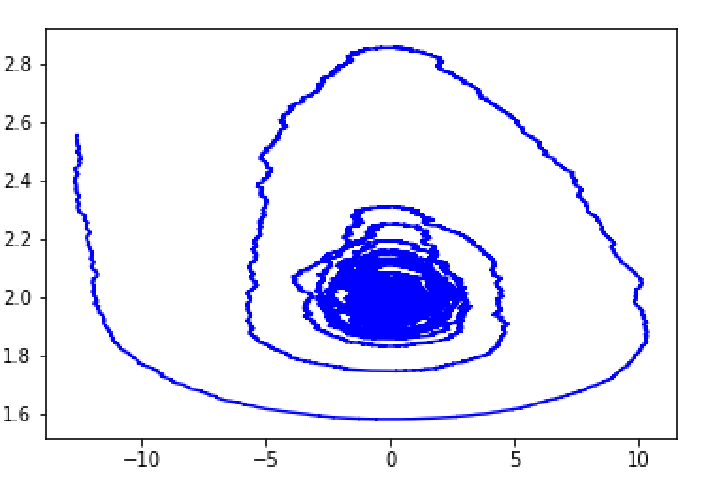

1. Does our system reach thermal equilibrium with a well-defined temperature: i.e. do the energies seem to converge to some sort of steady state?

Yes the energies converge into a steady state.

1. If so, is the well defined temperature to which our system converges the temperature used in the simulation: i.e. is the average energy toward the end of the trajectory approximately 𝑘𝐵𝑇 where 𝑇 is the temperature used in the BBK algorithm?